Recipe Pipeline
Code:
from airflow.decorators import dag, task
from datetime import datetime
import random

@dag(
dag_id="recipe_pipeline",
schedule="@daily",
catchup=False,
tags=["recipe"]
)
def recipe_pipeline():

@task
def get_ingredients(ds=None) -> dict:
print(f"Getting ingredients for {ds}")
return {
"dish": "Pasta",
"ingredients": ["pasta", "tomato sauce", "cheese", "garlic"]
}

@task
def prepare_dish(recipe: dict) -> dict:
dish = recipe["dish"]
ingredients = recipe["ingredients"]

print(f"Preparing {dish}...")
for i, item in enumerate(ingredients, start=1):
print(f"{i}. {item}")

return {
"dish": dish,
"ingredient_count": len(ingredients),
"status": "ready"
}

@task
def serve_dish(result: dict) -> str:
print(f"Serving {result['dish']} — {result['ingredient_count']} ingredients — Status: {result['status']}")
return f"Served: {result['dish']}"

@task.branch
def check_rating(result: dict) -> str:
rating = random.randint(1, 10)
print(f"Customer rating: {rating}/10")

if rating >= 7:
return "positive_review"
else:
return "needs_improvement"

@task
def positive_review() -> None:
print("Great dish! Marking as customer favourite.")

@task
def needs_improvement() -> None:
print("Recipe needs work. Adding to the improvement list.")

@task(trigger_rule="none_failed")
def end_of_service(served: str, ds=None) -> None:
print(served)
print(f"Kitchen closed for {ds}. All done!")

ingredients = get_ingredients()
prepared = prepare_dish(ingredients)
served = serve_dish(prepared)

review = check_rating(prepared)

review >> [positive_review(), needs_improvement()]

end_of_service(served)

dag_run = recipe_pipeline()

- Graph View — Run A: positive_review GREEN, needs_improvement pink (skipped), end_of_service
GREEN
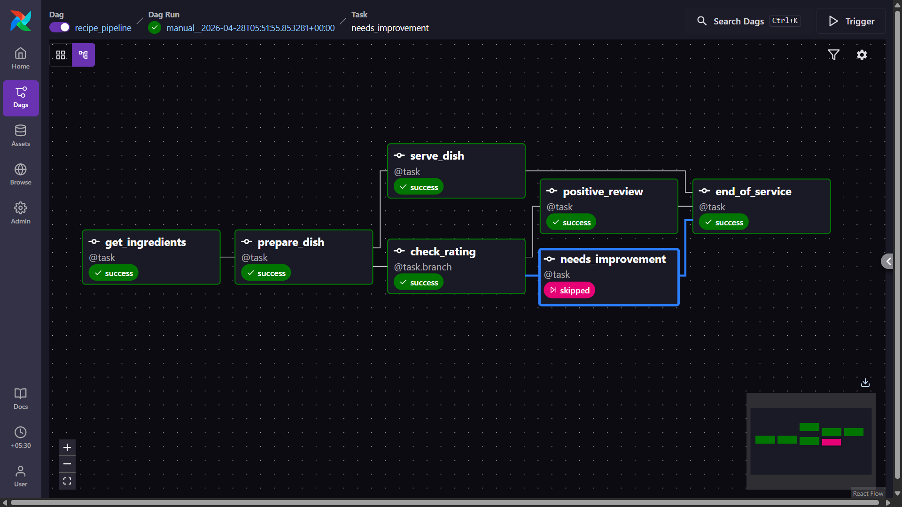
- Graph View — Run B: needs_improvement GREEN, positive_review pink (skipped), end_of_service
GREEN
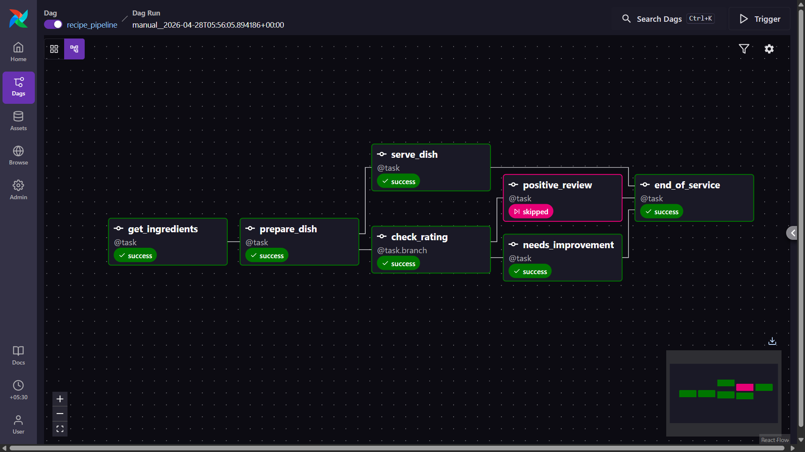
- Task Log of prepare_dish — showing the dish name and numbered ingredient list printed
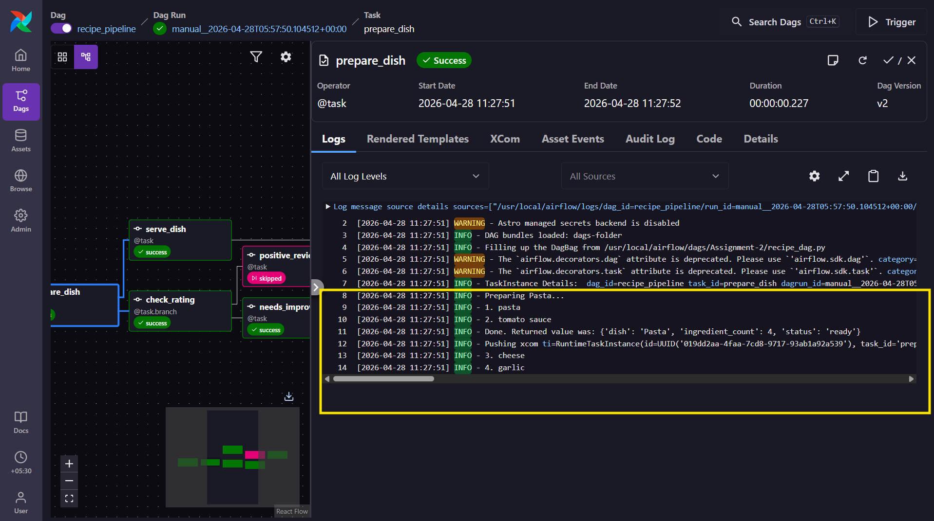
- Task Log of end_of_service — showing the served string and the closing message with ds
